




Project Report On
The Snake Game

SUBMITTED BY: SUBMITTED TO:
PANKAJ Ms. Saranjeet Kaur
UID: 25MCD10027 Associate Professor
CLASS: MCA (Data Science) SECTION: 25MCD1-A

Acknowledgement

I would like to express my sincere and heartfelt gratitude to Saranjeet Kaur Ma’am for her continuous guidance, patience, and encouragement throughout the completion of this project. Her valuable insights, constructive feedback, and constant motivation inspired me to stay curious and disciplined while developing this Snake Game project. Her deep knowledge of programming and logical problem-solving has been an invaluable source of learning, helping me strengthen my understanding of Python and its practical applications. Working under her guidance has not only improved my technical abilities but also enhanced my confidence in approaching complex coding challenges.
I would also like to extend my appreciation to all my faculty members in the Department of Computer Science for creating an engaging academic environment that constantly encourages innovation, exploration, and creativity. The classroom sessions, lab hours, and practical demonstrations provided me with a solid foundation in programming concepts, which were crucial for designing and implementing this project effectively.
A special note of thanks goes to my friends and classmates, who provided constant encouragement, support, and valuable suggestions during the development of the project. Their ideas helped me refine the user interface, improve the gameplay experience, and identify minor issues that needed fixing. Collaborating and discussing with them made this project not only an academic exercise but also a fun and memorable learning journey.
I am deeply grateful to the college administration for providing the necessary resources, computer lab facilities, and technical support that made the practical implementation of this project possible. Having access to the right tools and environment allowed me to experiment freely and learn through hands-on experience, which played a major role in successfully completing this work.
Lastly, I wish to thank my family for their endless encouragement, understanding, and emotional support throughout my studies. Their belief in me has always been my greatest source of strength and motivation. Without their support, the completion of this project would not have been possible.
Developing this Snake Game has been an enriching experience that allowed me to connect the theoretical knowledge gained in class with real-world programming practice. It helped me understand how logic, algorithms, and creativity come together to build something functional and enjoyable. This project has strengthened my passion for coding and problem-solving, and I am confident that the skills I have gained through this journey will help me in my future academic and professional endeavors.

Table of Content

S. No. | Name | Page no.
1 | Acknowledgement | 2
2 | Introduction /Background | 3
3 | Objective | 4
4 | Technologies Used | 5
5 | Requirements and System Design | 6
6 | Source Code & Output | 7-15
7 | Functionalities | 16
8 | Conclusion/Future Work/Learning Outcomes | 16-17
9 | Bibliography | 17

Introduction / Background
Games have always played an important role in understanding programming logic and interactive systems. Among all early video games, Snake is one of the simplest yet most fascinating. It first appeared in the 1970s on arcade systems and later became globally popular through Nokia phones in the late 1990s. Despite its simplicity, the game teaches important principles of control flow, logic, and algorithmic thinking, making it a perfect example for students learning programming.
This project revisits the classic Snake Game using Python and the Pygame library — an open-source multimedia library built for writing video games. The project not only recreates the fun gameplay but also demonstrates structured coding, user interaction, data persistence, and graphics handling.
Python, being beginner-friendly and highly versatile, provides an excellent platform to design a game with minimal code and maximum clarity. The graphical interface makes the project interactive, while the CSV-based score storage introduces a basic data management element. This helps bridge the gap between theoretical programming and real-world application development.
The purpose of developing this Snake Game is educational: to learn how user input, graphical rendering, and game loops interact in a real-time system. Moreover, the project illustrates how to handle external files for storing player data and how to implement event-driven programming, which is a key concept in both desktop and mobile application development.

Objective
The project’s primary aim is to create a fully functional Snake Game that uses Python’s graphical capabilities through Pygame. However, beyond just coding a game, the broader educational objectives include:
- Understanding how to build an event-driven application.
- Learning to handle keyboard inputs and use them to control objects on the screen.
- Exploring how to represent and update moving graphical objects dynamically.
- Using randomness to make gameplay unpredictable and engaging.
- Saving player data permanently using file handling (CSV format).
- Designing an appealing and user-friendly interface that includes start, game, and end screens.
- Building an interactive “Retry” system that allows players to replay without restarting the program.
- Developing modular and maintainable Python code by dividing the program into smaller functions.
By achieving these objectives, the project enhances both logical thinking and creativity — qualities essential for every computer science student.

Technologies Used
1. Python
Python serves as the backbone of the project. It is chosen for its simplicity, readability, and extensive library support. Python’s syntax allows for rapid development, which makes it ideal for experimenting with interactive programs.
2. Pygame Library
Pygame is a cross-platform set of Python modules designed for writing video games. It includes functionality for image handling, sounds, key inputs, event loops, and timing — all crucial for this project. It handles the rendering of the snake, food, and background, along with real-time event processing.
3. CSV File Handling
A CSV (Comma-Separated Values) file is used to save and retrieve scores. The use of the csv module allows easy writing of player names and their final scores to the file snake_scores.csv. This makes the game more personal and adds an element of persistence to an otherwise temporary session.
4. Additional Python Modules
- random: For generating random positions of food items.
- os: For checking if the score file exists before writing.
- sys: For exiting the program gracefully when the user quits.
The integration of these modules showcases how Python’s standard library can be combined with external packages to create rich multimedia applications.

Requirements and System Design
Hardware Requirements
- Processor: Intel Core i3 or higher
- RAM: Minimum 4 GB
- Hard Disk: At least 200 MB free space
- Display: 1366×768 resolution or above
- Keyboard: For directional input
Software Requirements
- Operating System: Windows 10 / 11, macOS, or Linux
- Python Version: 3.10 or above
- Pygame Library Installed: pip install pygame
System Design Overview
The design of the Snake Game follows a modular structure, separating each part of the functionality into logical units:
- User Input Module: Takes the player’s name through a text input window before starting.
- Game Initialization: Sets the window size, color themes, and initial game variables like snake position and speed.
- Main Game Loop: Runs continuously until the game is over. It listens for key presses, updates the snake’s position, checks for collisions, and redraws the screen each frame.
- Collision Detection System: Determines if the snake hits the wall or itself. If true, triggers the game-over function.
- Score System: Increments score when the snake eats food and updates the display in real time.
- Storage System: Writes the player’s name and score to the CSV file.
- Game Over and Retry System: Displays final results and allows the player to retry or quit.
This logical separation of concerns makes the code easier to understand, debug, and extend.

Source Code & Output
The full source code (snakegame.py) initializes Pygame, creates a window, defines colors, and manages the snake’s movement using arrow keys. The game uses a while loop to continuously update the screen, check collisions, and render objects.

#####
import pygame
import random
import csv
import os
import sys

# Initialize pygame
pygame.init()

# Window dimensions
WINDOW_WIDTH = 1000
WINDOW_HEIGHT = 800 # Reduced height so it fits on most screens
HEADER_HEIGHT = 60 # Top area for player info

# Colors
BLACK = (0, 0, 0)
WHITE = (255, 255, 255)
GREEN = (0, 255, 0)
RED = (255, 0, 0)
BLUE = (50, 150, 255)
GRAY = (50, 50, 50)

# Font setup
font = pygame.font.SysFont('arial', 25, bold=True)
large_font = pygame.font.SysFont('arial', 50, bold=True)

# CSV file setup
csv_file = "snake_scores.csv"
if not os.path.exists(csv_file):
with open(csv_file, mode="w", newline="") as file:
writer = csv.writer(file)
writer.writerow(["Player", "Score"])

# Ask player name before starting
def get_player_name():
input_box = pygame.Rect(WINDOW_WIDTH//2 - 150, WINDOW_HEIGHT//2 - 25, 300, 50)
color_inactive = GRAY
color_active = BLUE
color = color_inactive
active = False
text = ''
done = False
screen = pygame.display.set_mode((WINDOW_WIDTH, WINDOW_HEIGHT))
pygame.display.set_caption("Snake Game - Enter Name")

while not done:
for event in pygame.event.get():
if event.type == pygame.QUIT:
pygame.quit()
sys.exit()
if event.type == pygame.MOUSEBUTTONDOWN:
if input_box.collidepoint(event.pos):
active = not active
else:
active = False
color = color_active if active else color_inactive
if event.type == pygame.KEYDOWN:
if active:
if event.key == pygame.K_RETURN:
done = True
elif event.key == pygame.K_BACKSPACE:
text = text[:-1]
else:
text += event.unicode

screen.fill(BLACK)
txt_surface = font.render(text, True, WHITE)
width = max(300, txt_surface.get_width()+10)
input_box.w = width
screen.blit(txt_surface, (input_box.x+5, input_box.y+10))
pygame.draw.rect(screen, color, input_box, 2)
prompt = large_font.render("Enter Your Name:", True, WHITE)
screen.blit(prompt, (WINDOW_WIDTH//2 - 200, WINDOW_HEIGHT//2 - 100))
pygame.display.flip()

return text if text.strip() else "Player"

# Initialize game function
def start_game(player_name):
screen = pygame.display.set_mode((WINDOW_WIDTH, WINDOW_HEIGHT))
pygame.display.set_caption("Snake Game")

clock = pygame.time.Clock()

# Snake settings
snake_block = 20
snake_speed = 15

# Initial snake position
snake = [(100, 100)]
direction = (snake_block, 0)

# Food position
food = (random.randrange(0, (WINDOW_WIDTH - snake_block)//snake_block) * snake_block,
random.randrange(HEADER_HEIGHT//snake_block, (WINDOW_HEIGHT - snake_block)//snake_block) * snake_block)

score = 0
game_over = False

def draw_snake(snake_list):
for x in snake_list:
pygame.draw.rect(screen, GREEN, [x[0], x[1], snake_block, snake_block])

def show_score():
pygame.draw.rect(screen, GRAY, (0, 0, WINDOW_WIDTH, HEADER_HEIGHT)) # header panel
player_text = font.render(f"Player: {player_name}", True, WHITE)
score_text = font.render(f"Score: {score}", True, WHITE)
screen.blit(player_text, (20, 15))
screen.blit(score_text, (WINDOW_WIDTH - 150, 15))

def save_score():
with open(csv_file, mode="a", newline="") as file:
writer = csv.writer(file)
writer.writerow([player_name, score])

def game_over_screen():
screen.fill(BLACK)
msg1 = large_font.render("Game Over!", True, RED)
msg2 = font.render(f"Your Score: {score}", True, WHITE)
retry_button = pygame.Rect(WINDOW_WIDTH//2 - 120, WINDOW_HEIGHT//2, 100, 50)
quit_button = pygame.Rect(WINDOW_WIDTH//2 + 20, WINDOW_HEIGHT//2, 100, 50)
pygame.draw.rect(screen, BLUE, retry_button)
pygame.draw.rect(screen, BLUE, quit_button)
screen.blit(msg1, (WINDOW_WIDTH//2 - 130, WINDOW_HEIGHT//2 - 100))
screen.blit(msg2, (WINDOW_WIDTH//2 - 70, WINDOW_HEIGHT//2 - 40))
screen.blit(font.render("Retry", True, WHITE), (retry_button.x + 20, retry_button.y + 10))
screen.blit(font.render("Quit", True, WHITE), (quit_button.x + 30, quit_button.y + 10))
pygame.display.flip()

waiting = True
while waiting:
for event in pygame.event.get():
if event.type == pygame.QUIT:
pygame.quit()
sys.exit()
if event.type == pygame.MOUSEBUTTONDOWN:
if retry_button.collidepoint(event.pos):
waiting = False
start_game(player_name)
elif quit_button.collidepoint(event.pos):
pygame.quit()
sys.exit()

# Main loop
while not game_over:
for event in pygame.event.get():
if event.type == pygame.QUIT:
save_score()
pygame.quit()
sys.exit()
if event.type == pygame.KEYDOWN:
if event.key == pygame.K_LEFT and direction != (snake_block, 0):
direction = (-snake_block, 0)
elif event.key == pygame.K_RIGHT and direction != (-snake_block, 0):
direction = (snake_block, 0)
elif event.key == pygame.K_UP and direction != (0, snake_block):
direction = (0, -snake_block)
elif event.key == pygame.K_DOWN and direction != (0, -snake_block):
direction = (0, snake_block)

x = snake[-1][0] + direction[0]
y = snake[-1][1] + direction[1]

# Game boundaries
if x < 0 or x >= WINDOW_WIDTH or y < HEADER_HEIGHT or y >= WINDOW_HEIGHT:
save_score()
game_over_screen()

new_head = (x, y)
snake.append(new_head)

# Check if snake eats food
if new_head == food:
score += 10
food = (random.randrange(0, (WINDOW_WIDTH - snake_block)//snake_block) * snake_block,
random.randrange(HEADER_HEIGHT//snake_block, (WINDOW_HEIGHT - snake_block)//snake_block) * snake_block)
else:
snake.pop(0)

# Check self collision
if len(snake) != len(set(snake)):
save_score()
game_over_screen()

# Draw everything
screen.fill(BLACK)
show_score()
pygame.draw.rect(screen, RED, [food[0], food[1], snake_block, snake_block])
draw_snake(snake)
pygame.display.flip()
clock.tick(snake_speed)

# Run the game
player_name = get_player_name()
start_game(player_name)

####
Highlights from the Code:
- Snake Rendering: Each segment of the snake is drawn using rectangles (pygame.draw.rect).
- Movement Logic: Controlled via pygame.KEYDOWN events for UP, DOWN, LEFT, and RIGHT keys.
- Food Placement: Randomly generated positions using the random module.
- Collision Check: Uses simple coordinate comparisons to detect hits.
- Score Storage: Automatically appends results to snake_scores.csv.
Sample CSV Output
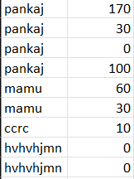
Graphical Output
- Start Screen: Asks for the player’s name.
- Gameplay: Displays the snake, moving food, and live score bar at the top.
- Game Over Screen: Shows score and buttons for Retry or Quit.
These outputs confirm that the project successfully implements graphical interaction, file operations, and game logic cohesively.
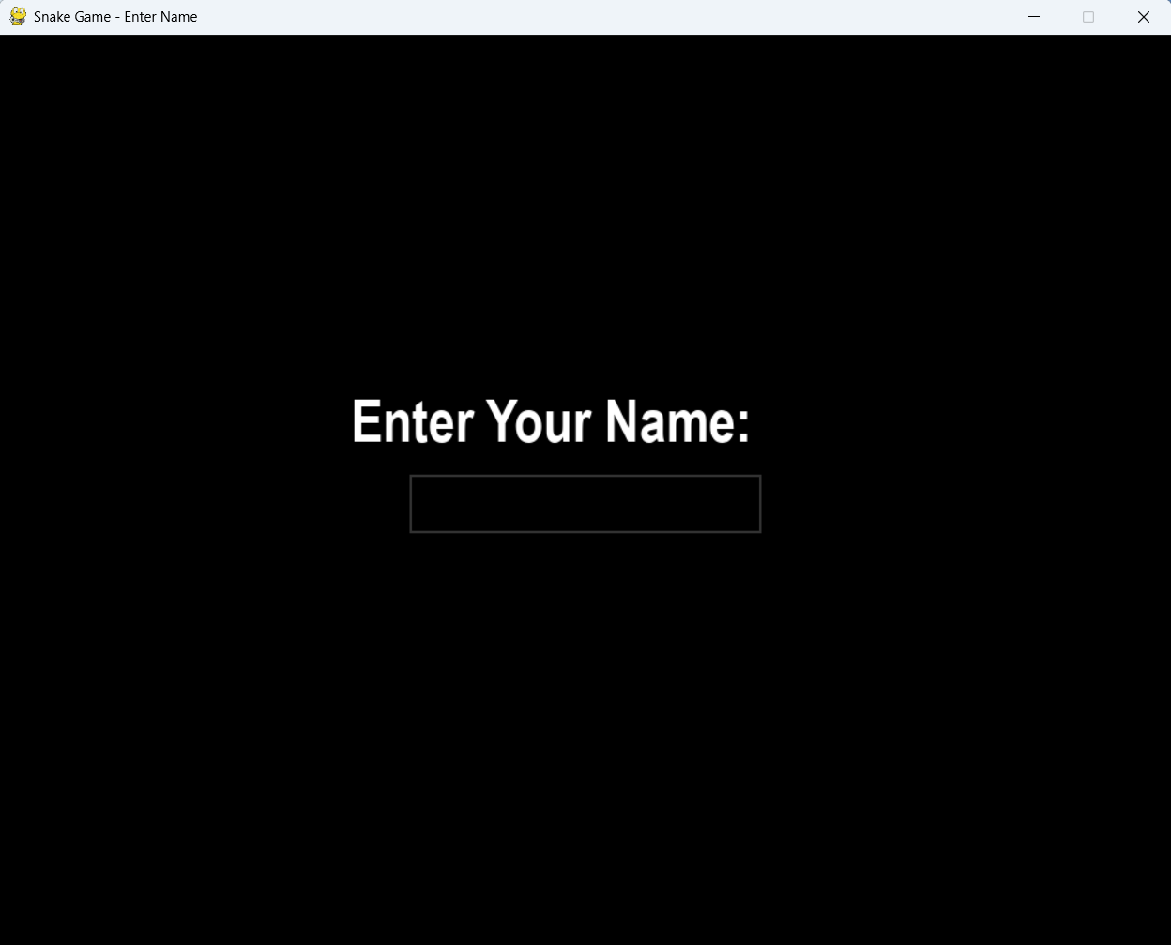

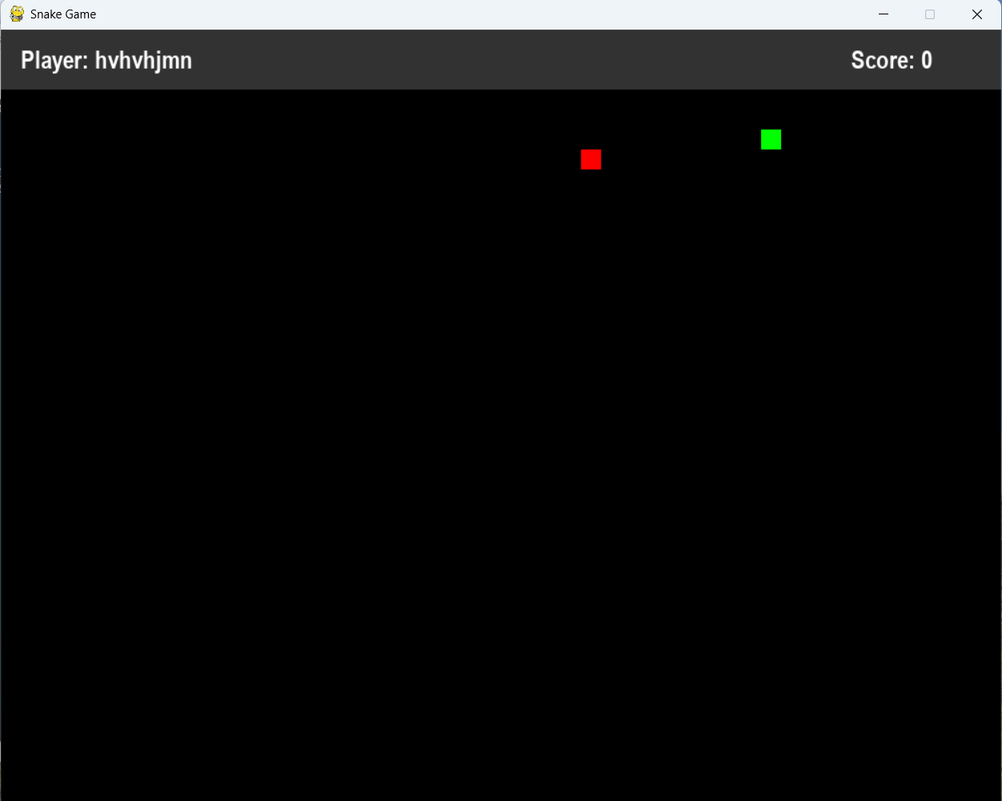

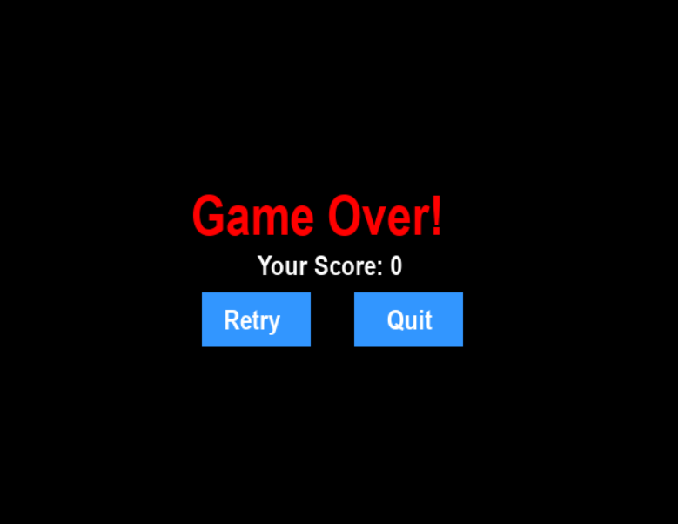

Functionalities
- Player Name Input: Interactive interface for entering player details.
- Dynamic Gameplay: Snake moves smoothly across the screen; speed remains constant.
- Score Tracking: Score increases by 10 each time the snake eats food.
- Collision Detection: Ends game when snake hits walls or itself.
- Retry Option: Players can instantly restart after losing.
- Data Storage: Player scores are automatically saved to a CSV file.
- Game Speed Control: The frame rate (snake_speed) can be adjusted for difficulty.
- Header Display: Displays current player name and score.
- Smooth UI: All transitions and screen updates occur without lag due to the Pygame clock system.

Testing and Validation
To ensure stability, the game was tested under different conditions:
- Boundary Tests: Confirmed that collisions at window borders correctly trigger game over.
- Input Tests: Verified smooth response to all arrow keys.
- Multiple Players: Tested consecutive sessions with different player names — scores stored correctly in CSV.
- Replay Functionality: Retry button successfully restarts the game without needing to close the window.
- Performance: Maintained steady frame rate even after the snake grew longer.
These results confirm that the game logic and user interface function reliably.

Conclusion / Future Work / Learning Outcomes
Conclusion
This project demonstrates how simple programming principles can be combined to create an interactive and enjoyable product. The Snake Game project bridges the gap between theory and practical application, showcasing how loops, conditions, data structures, and user interaction form the core of most modern applications.
The project achieves its main objectives: to develop a GUI-based game, manage user data, and demonstrate the use of Pygame for creating real-time visual feedback. It also lays the foundation for more advanced game development concepts such as frame management, object-oriented design, and sound integration.
Future Work
- Levels and Difficulty: Introduce increasing difficulty as the player’s score rises.
- Leaderboard: Display top 5 scores directly from the CSV file.
- Sound Effects: Add background music and eating/collision sounds for immersion.
- Themes and Skins: Allow players to change colors or backgrounds.
- Mobile/Web Version: Port to Android or browser using Kivy or Pygbag frameworks.
- Obstacle Mode: Add barriers that increase the challenge.
Learning Outcomes
- Developed understanding of game loops, rendering, and event handling.
- Learned to integrate file handling with GUI applications.
- Understood the importance of structured and modular code.
- Gained practical experience in real-time input processing.
- Enhanced creativity and logical thinking through problem-solving.
This project was not just a coding exercise—it was an exploration of how programming can create dynamic, visual experiences that engage the user in real time.

Bibliography
- Pygame Documentation – https://www.pygame.org/docs/
- Python Official Docs – https://docs.python.org/3/
- GeeksforGeeks – Tutorials on Pygame and Game Loops
- Real Python – “Game Development with Pygame”
- Stack Overflow – Discussions on collision detection and event handling
- TutorialsPoint – Basics of Python Game Programming

